RPROGRAMMING

ACCIDENTS

PREDICTION :

STATEWISE,UT,CITYWISE ACCIDENT HISTORY YEAR OF 2020-2021

Abisha.K

I M.SC(data analytics)

DESCRIPTION :

* Accidents are defined as unintended and unplanned events that result in physical and/or property damage. They can range from minor fender benders to serious collisions and can be caused by a variety of factors, such as poor driving conditions, driver error, vehicle malfunction, and hazardous roadways. Accidents often cause property damage, physical injury, or even death.

**ASSUMPTIONS :**

From this dataset,

* Accidents are occurs in many sectors, I can take some accidents that is : road accidents , railway accidents , traffic accidents to predict on state wise , UT(union territory) , and city wise in the year of 2020-2021 respectively.

I can assume that : -

* Road accidents have increased significantly in 2021 as compared to 2020 across all states in India, Railway accidents have increased by 2021 as compared to 2020, Railway crossing accidents have decreased by 2021 as compared to 2020, Total traffic accidents have increased by 2021 as compared to 2020.
* Overall increase in the number of traffic accidents across all cities in India, with an increase of from 2020 to 2021.
* The data is from the Ministry of Road Transport and Highways, Government of India and is an estimate of the number of road, railway, and railway crossing accidents in 2020 and 2021. The data also shows the percentage change in accidents from 2020 to 2021.

CODING :

install.packages("dplyr")

## Installing package into '/cloud/lib/x86_64-pc-linux-gnu-library/4.2'  
## (as 'lib' is unspecified)

library(dplyr)

##   
## Attaching package: 'dplyr'

## The following objects are masked from 'package:stats':  
##   
## filter, lag

## The following objects are masked from 'package:base':  
##   
## intersect, setdiff, setequal, union

library(MASS)

##   
## Attaching package: 'MASS'

## The following object is masked from 'package:dplyr':  
##   
## select

data <- read.csv("NCRB_ADSI-2021_Table_1A.1.csv")  
data

## Category State.UT.City  
## 1 State Andhra Pradesh  
## 2 State Arunachal Pradesh  
## 3 State Assam  
## 4 State Bihar  
## 5 State Chhattisgarh  
## 6 State Goa  
## 7 State Gujarat  
## 8 State Haryana  
## 9 State Himachal Pradesh  
## 10 State Jharkhand  
## 11 State Karnataka  
## 12 State Kerala  
## 13 State Madhya Pradesh  
## 14 State Maharashtra  
## 15 State Manipur  
## 16 State Meghalaya  
## 17 State Mizoram  
## 18 State Nagaland  
## 19 State Odisha  
## 20 State Punjab  
## 21 State Rajasthan  
## 22 State Sikkim  
## 23 State Tamil Nadu  
## 24 State Telangana  
## 25 State Tripura  
## 26 State Uttar Pradesh  
## 27 State Uttarakhand  
## 28 State West Bengal  
## 29 State Total (States)  
## 30 UT Andaman and Nicobar Islands  
## 31 UT Chandigarh  
## 32 UT Dadra and Nagar Haveli and Daman and Diu  
## 33 UT Delhi  
## 34 UT Jammu and Kashmir  
## 35 UT Ladakh  
## 36 UT Lakshadweep  
## 37 UT Puducherry  
## 38 UT Total (UTs)  
## 39 Total (All India) Total (All India)  
## 40 City Agra  
## 41 City Ahmedabad  
## 42 City Allahabad  
## 43 City Amritsar  
## 44 City Asansol  
## 45 City Aurangabad  
## 46 City Bengaluru  
## 47 City Bhopal  
## 48 City Chandigarh (City)  
## 49 City Chennai  
## 50 City Coimbatore  
## 51 City Delhi (City)  
## 52 City Dhanbad  
## 53 City Durg Bhilainagar  
## 54 City Faridabad  
## 55 City Ghaziabad  
## 56 City Gwalior  
## 57 City Hyderabad  
## 58 City Indore  
## 59 City Jabalpur  
## 60 City Jaipur  
## 61 City Jamshedpur  
## 62 City Jodhpur  
## 63 City Kannur  
## 64 City Kanpur  
## 65 City Kochi  
## 66 City Kolkata  
## 67 City Kollam  
## 68 City Kota  
## 69 City Kozhikode  
## 70 City Lucknow  
## 71 City Ludhiana  
## 72 City Madurai  
## 73 City Malappuram  
## 74 City Meerut  
## 75 City Mumbai  
## 76 City Nagpur  
## 77 City Nasik  
## 78 City Patna  
## 79 City Pune  
## 80 City Raipur  
## 81 City Rajkot  
## 82 City Ranchi  
## 83 City Srinagar  
## 84 City Surat  
## 85 City Thiruvananthapuram  
## 86 City Thrissur  
## 87 City Tiruchirappalli  
## 88 City Vadodara  
## 89 City Varanasi  
## 90 City Vasai Virar  
## 91 City Vijayawada  
## 92 City Vishakhapatnam  
## 93 City Total (Cities)  
## Road.Accidents...2020 Road.Accidents...2021 Road.Accidents.....Var  
## 1 17924 21556 20.3  
## 2 159 261 64.2  
## 3 6737 7069 4.9  
## 4 8639 9553 10.6  
## 5 11674 12395 6.2  
## 6 2375 2850 20.0  
## 7 13407 15200 13.4  
## 8 9506 10049 5.7  
## 9 2235 2408 7.7  
## 10 4405 4728 7.3  
## 11 34178 34647 1.4  
## 12 27799 32759 17.8  
## 13 42396 48219 13.7  
## 14 22211 26598 19.8  
## 15 432 366 -15.3  
## 16 205 244 19.0  
## 17 47 64 36.2  
## 18 27 25 -7.4  
## 19 9817 10983 11.9  
## 20 5173 6097 17.9  
## 21 19121 20954 9.6  
## 22 108 122 13.0  
## 23 45484 55682 22.4  
## 24 19172 21315 11.2  
## 25 466 478 2.6  
## 26 28653 33711 17.7  
## 27 1050 1405 33.8  
## 28 10843 11501 6.1  
## 29 344243 391239 13.7  
## 30 141 117 -17.0  
## 31 157 208 32.5  
## 32 98 140 42.9  
## 33 4187 4720 12.7  
## 34 4861 5402 11.1  
## 35 139 237 70.5  
## 36 1 4 300.0  
## 37 969 1049 8.3  
## 38 10553 11877 12.5  
## 39 354796 403116 13.6  
## 40 216 160 -25.9  
## 41 1185 1433 20.9  
## 42 221 594 168.8  
## 43 100 98 -2.0  
## 44 427 285 -33.3  
## 45 372 478 28.5  
## 46 3233 3213 -0.6  
## 47 1590 1891 18.9  
## 48 157 208 32.5  
## 49 4389 5034 14.7  
## 50 707 866 22.5  
## 51 4028 4505 11.8  
## 52 164 187 14.0  
## 53 603 625 3.6  
## 54 524 538 2.7  
## 55 154 296 92.2  
## 56 1013 1034 2.1  
## 57 2064 2273 10.1  
## 58 2101 2618 24.6  
## 59 1916 1802 -5.9  
## 60 1940 2166 11.6  
## 61 119 152 27.7  
## 62 481 595 23.7  
## 63 504 1110 120.2  
## 64 418 593 41.9  
## 65 1360 1781 31.0  
## 66 1683 1519 -9.7  
## 67 1411 1552 10.0  
## 68 353 368 4.2  
## 69 1003 1377 37.3  
## 70 1010 1063 5.2  
## 71 388 478 23.2  
## 72 530 618 16.6  
## 73 612 686 12.1  
## 74 377 348 -7.7  
## 75 418 493 17.9  
## 76 890 1024 15.1  
## 77 98 142 44.9  
## 78 373 384 2.9  
## 79 174 304 74.7  
## 80 907 932 2.8  
## 81 432 363 -16.0  
## 82 247 183 -25.9  
## 83 276 331 19.9  
## 84 575 670 16.5  
## 85 1214 1438 18.5  
## 86 1464 1719 17.4  
## 87 398 399 0.3  
## 88 481 464 -3.5  
## 89 120 133 10.8  
## 90 274 352 28.5  
## 91 991 1228 23.9  
## 92 1144 2339 104.5  
## 93 47829 55442 15.9  
## Railway.Accidents...2020 Railway.Accidents...2021 Railway.Accidents.....Var  
## 1 611 755 23.6  
## 2 0 0 NA  
## 3 413 459 11.1  
## 4 780 1147 47.1  
## 5 328 412 25.6  
## 6 23 49 113.0  
## 7 490 571 16.5  
## 8 523 806 54.1  
## 9 0 0 NA  
## 10 274 284 3.6  
## 11 0 0 NA  
## 12 110 171 55.5  
## 13 820 1078 31.5  
## 14 2697 3488 29.3  
## 15 0 0 NA  
## 16 0 0 NA  
## 17 0 0 NA  
## 18 0 0 NA  
## 19 279 306 9.7  
## 20 342 615 79.8  
## 21 429 669 55.9  
## 22 0 0 NA  
## 23 959 1407 46.7  
## 24 333 408 22.5  
## 25 2 4 100.0  
## 26 1560 2223 42.5  
## 27 5 25 400.0  
## 28 1505 2425 61.1  
## 29 12483 17302 38.6  
## 30 0 0 NA  
## 31 0 0 NA  
## 32 0 0 NA  
## 33 526 676 28.5  
## 34 9 15 66.7  
## 35 0 0 NA  
## 36 0 0 NA  
## 37 0 0 NA  
## 38 535 691 29.2  
## 39 13018 17993 38.2  
## 40 0 0 NA  
## 41 30 33 10.0  
## 42 0 0 NA  
## 43 0 0 NA  
## 44 4 7 75.0  
## 45 22 43 95.5  
## 46 0 0 NA  
## 47 28 31 10.7  
## 48 0 0 NA  
## 49 0 0 NA  
## 50 0 0 NA  
## 51 526 676 28.5  
## 52 0 0 NA  
## 53 14 29 107.1  
## 54 0 0 NA  
## 55 21 18 -14.3  
## 56 0 0 NA  
## 57 1 0 -100.0  
## 58 11 9 -18.2  
## 59 30 7 -76.7  
## 60 101 115 13.9  
## 61 0 0 NA  
## 62 0 7 NA  
## 63 10 23 130.0  
## 64 31 0 -100.0  
## 65 0 12 NA  
## 66 0 0 NA  
## 67 1 1 0.0  
## 68 0 0 NA  
## 69 10 9 -10.0  
## 70 3 36 1100.0  
## 71 0 0 NA  
## 72 0 0 NA  
## 73 0 5 NA  
## 74 0 0 NA  
## 75 0 0 NA  
## 76 31 37 19.4  
## 77 22 27 22.7  
## 78 0 0 NA  
## 79 15 22 46.7  
## 80 31 47 51.6  
## 81 10 10 0.0  
## 82 0 0 NA  
## 83 0 0 NA  
## 84 11 34 209.1  
## 85 0 0 NA  
## 86 8 0 -100.0  
## 87 0 0 NA  
## 88 8 8 0.0  
## 89 20 29 45.0  
## 90 0 0 NA  
## 91 0 0 NA  
## 92 0 5 NA  
## 93 999 1280 28.1  
## Railway.Crossing.Accidents...2020 Railway.Crossing.Accidents...2021  
## 1 0 0  
## 2 0 0  
## 3 8 3  
## 4 191 163  
## 5 4 0  
## 6 0 0  
## 7 1 0  
## 8 57 160  
## 9 0 0  
## 10 22 117  
## 11 0 0  
## 12 89 121  
## 13 144 196  
## 14 0 0  
## 15 0 0  
## 16 0 0  
## 17 0 0  
## 18 3 9  
## 19 2 0  
## 20 2 1  
## 21 0 0  
## 22 0 0  
## 23 0 1  
## 24 0 0  
## 25 23 33  
## 26 380 575  
## 27 3 0  
## 28 83 164  
## 29 1012 1543  
## 30 0 0  
## 31 0 0  
## 32 0 0  
## 33 2 0  
## 34 0 7  
## 35 0 0  
## 36 0 0  
## 37 0 0  
## 38 2 7  
## 39 1014 1550  
## 40 16 0  
## 41 0 0  
## 42 0 0  
## 43 0 0  
## 44 0 0  
## 45 0 0  
## 46 0 0  
## 47 2 25  
## 48 0 0  
## 49 0 0  
## 50 0 0  
## 51 2 0  
## 52 0 0  
## 53 0 0  
## 54 0 0  
## 55 0 0  
## 56 21 18  
## 57 0 0  
## 58 0 0  
## 59 0 1  
## 60 0 0  
## 61 0 0  
## 62 0 0  
## 63 0 0  
## 64 34 69  
## 65 20 1  
## 66 0 0  
## 67 8 12  
## 68 0 0  
## 69 0 6  
## 70 8 9  
## 71 0 0  
## 72 0 0  
## 73 0 0  
## 74 14 14  
## 75 0 0  
## 76 0 0  
## 77 0 0  
## 78 0 0  
## 79 0 0  
## 80 3 0  
## 81 0 0  
## 82 0 0  
## 83 0 0  
## 84 0 0  
## 85 11 17  
## 86 0 0  
## 87 0 0  
## 88 0 0  
## 89 0 0  
## 90 0 0  
## 91 0 0  
## 92 0 0  
## 93 139 172  
## Railway.Crossing.Accidents.....Var Total.Traffic.Accidents...2020  
## 1 NA 18535  
## 2 NA 159  
## 3 -62.5 7158  
## 4 -14.7 9610  
## 5 -100.0 12006  
## 6 NA 2398  
## 7 -100.0 13898  
## 8 180.7 10086  
## 9 NA 2235  
## 10 431.8 4701  
## 11 NA 34178  
## 12 36.0 27998  
## 13 36.1 43360  
## 14 NA 24908  
## 15 NA 432  
## 16 NA 205  
## 17 NA 47  
## 18 200.0 30  
## 19 -100.0 10098  
## 20 -50.0 5517  
## 21 NA 19550  
## 22 NA 108  
## 23 NA 46443  
## 24 NA 19505  
## 25 43.5 491  
## 26 51.3 30593  
## 27 -100.0 1058  
## 28 97.6 12431  
## 29 52.5 357738  
## 30 NA 141  
## 31 NA 157  
## 32 NA 98  
## 33 -100.0 4715  
## 34 NA 4870  
## 35 NA 139  
## 36 NA 1  
## 37 NA 969  
## 38 250.0 11090  
## 39 52.9 368828  
## 40 -100.0 232  
## 41 NA 1215  
## 42 NA 221  
## 43 NA 100  
## 44 NA 431  
## 45 NA 394  
## 46 NA 3233  
## 47 1150.0 1620  
## 48 NA 157  
## 49 NA 4389  
## 50 NA 707  
## 51 -100.0 4556  
## 52 NA 164  
## 53 NA 617  
## 54 NA 524  
## 55 NA 175  
## 56 -14.3 1034  
## 57 NA 2065  
## 58 NA 2112  
## 59 NA 1946  
## 60 NA 2041  
## 61 NA 119  
## 62 NA 481  
## 63 NA 514  
## 64 102.9 483  
## 65 -95.0 1380  
## 66 NA 1683  
## 67 50.0 1420  
## 68 NA 353  
## 69 NA 1013  
## 70 12.5 1021  
## 71 NA 388  
## 72 NA 530  
## 73 NA 612  
## 74 0.0 391  
## 75 NA 418  
## 76 NA 921  
## 77 NA 120  
## 78 NA 373  
## 79 NA 189  
## 80 -100.0 941  
## 81 NA 442  
## 82 NA 247  
## 83 NA 276  
## 84 NA 586  
## 85 54.5 1225  
## 86 NA 1472  
## 87 NA 398  
## 88 NA 489  
## 89 NA 140  
## 90 NA 274  
## 91 NA 991  
## 92 NA 1144  
## 93 23.7 48967  
## Total.Traffic.Accidents...2021 Total.Traffic.Accidents.....Var X..Share  
## 1 22311 20.4 5.3  
## 2 261 64.2 0.1  
## 3 7531 5.2 1.8  
## 4 10863 13.0 2.6  
## 5 12807 6.7 3.0  
## 6 2899 20.9 0.7  
## 7 15771 13.5 3.7  
## 8 11015 9.2 2.6  
## 9 2408 7.7 0.6  
## 10 5129 9.1 1.2  
## 11 34647 1.4 8.2  
## 12 33051 18.0 7.8  
## 13 49493 14.1 11.7  
## 14 30086 20.8 7.1  
## 15 366 -15.3 0.1  
## 16 244 19.0 0.1  
## 17 64 36.2 0.0  
## 18 34 13.3 0.0  
## 19 11289 11.8 2.7  
## 20 6713 21.7 1.6  
## 21 21623 10.6 5.1  
## 22 122 13.0 0.0  
## 23 57090 22.9 13.5  
## 24 21723 11.4 5.1  
## 25 515 4.9 0.1  
## 26 36509 19.3 8.6  
## 27 1430 35.2 0.3  
## 28 14090 13.3 3.3  
## 29 410084 14.6 97.0  
## 30 117 -17.0 0.0  
## 31 208 32.5 0.0  
## 32 140 42.9 0.0  
## 33 5396 14.4 1.3  
## 34 5424 11.4 1.3  
## 35 237 70.5 0.1  
## 36 4 300.0 0.0  
## 37 1049 8.3 0.2  
## 38 12575 13.4 3.0  
## 39 422659 14.6 100.0  
## 40 160 -31.0 0.3  
## 41 1466 20.7 2.6  
## 42 594 168.8 1.0  
## 43 98 -2.0 0.2  
## 44 292 -32.3 0.5  
## 45 521 32.2 0.9  
## 46 3213 -0.6 5.6  
## 47 1947 20.2 3.4  
## 48 208 32.5 0.4  
## 49 5034 14.7 8.8  
## 50 866 22.5 1.5  
## 51 5181 13.7 9.1  
## 52 187 14.0 0.3  
## 53 654 6.0 1.1  
## 54 538 2.7 0.9  
## 55 314 79.4 0.6  
## 56 1052 1.7 1.8  
## 57 2273 10.1 4.0  
## 58 2627 24.4 4.6  
## 59 1810 -7.0 3.2  
## 60 2281 11.8 4.0  
## 61 152 27.7 0.3  
## 62 602 25.2 1.1  
## 63 1133 120.4 2.0  
## 64 662 37.1 1.2  
## 65 1794 30.0 3.2  
## 66 1519 -9.7 2.7  
## 67 1565 10.2 2.8  
## 68 368 4.2 0.6  
## 69 1392 37.4 2.4  
## 70 1108 8.5 1.9  
## 71 478 23.2 0.8  
## 72 618 16.6 1.1  
## 73 691 12.9 1.2  
## 74 362 -7.4 0.6  
## 75 493 17.9 0.9  
## 76 1061 15.2 1.9  
## 77 169 40.8 0.3  
## 78 384 2.9 0.7  
## 79 326 72.5 0.6  
## 80 979 4.0 1.7  
## 81 373 -15.6 0.7  
## 82 183 -25.9 0.3  
## 83 331 19.9 0.6  
## 84 704 20.1 1.2  
## 85 1455 18.8 2.6  
## 86 1719 16.8 3.0  
## 87 399 0.3 0.7  
## 88 472 -3.5 0.8  
## 89 162 15.7 0.3  
## 90 352 28.5 0.6  
## 91 1228 23.9 2.2  
## 92 2344 104.9 4.1  
## 93 56894 16.2 100.0

#view(data)  
nrow(data)

## [1] 93

ncol(data)

## [1] 15

colnames(data)

## [1] "Category" "State.UT.City"   
## [3] "Road.Accidents...2020" "Road.Accidents...2021"   
## [5] "Road.Accidents.....Var" "Railway.Accidents...2020"   
## [7] "Railway.Accidents...2021" "Railway.Accidents.....Var"   
## [9] "Railway.Crossing.Accidents...2020" "Railway.Crossing.Accidents...2021"   
## [11] "Railway.Crossing.Accidents.....Var" "Total.Traffic.Accidents...2020"   
## [13] "Total.Traffic.Accidents...2021" "Total.Traffic.Accidents.....Var"   
## [15] "X..Share"

str(data)

## 'data.frame': 93 obs. of 15 variables:  
## $ Category : chr "State" "State" "State" "State" ...  
## $ State.UT.City : chr "Andhra Pradesh" "Arunachal Pradesh" "Assam" "Bihar" ...  
## $ Road.Accidents...2020 : int 17924 159 6737 8639 11674 2375 13407 9506 2235 4405 ...  
## $ Road.Accidents...2021 : int 21556 261 7069 9553 12395 2850 15200 10049 2408 4728 ...  
## $ Road.Accidents.....Var : num 20.3 64.2 4.9 10.6 6.2 20 13.4 5.7 7.7 7.3 ...  
## $ Railway.Accidents...2020 : int 611 0 413 780 328 23 490 523 0 274 ...  
## $ Railway.Accidents...2021 : int 755 0 459 1147 412 49 571 806 0 284 ...  
## $ Railway.Accidents.....Var : num 23.6 NA 11.1 47.1 25.6 113 16.5 54.1 NA 3.6 ...  
## $ Railway.Crossing.Accidents...2020 : int 0 0 8 191 4 0 1 57 0 22 ...  
## $ Railway.Crossing.Accidents...2021 : int 0 0 3 163 0 0 0 160 0 117 ...  
## $ Railway.Crossing.Accidents.....Var: num NA NA -62.5 -14.7 -100 ...  
## $ Total.Traffic.Accidents...2020 : int 18535 159 7158 9610 12006 2398 13898 10086 2235 4701 ...  
## $ Total.Traffic.Accidents...2021 : int 22311 261 7531 10863 12807 2899 15771 11015 2408 5129 ...  
## $ Total.Traffic.Accidents.....Var : num 20.4 64.2 5.2 13 6.7 20.9 13.5 9.2 7.7 9.1 ...  
## $ X..Share : num 5.3 0.1 1.8 2.6 3 0.7 3.7 2.6 0.6 1.2 ...

summary(data)

## Category State.UT.City Road.Accidents...2020  
## Length:93 Length:93 Min. : 1   
## Class :character Class :character 1st Qu.: 353   
## Mode :character Mode :character Median : 969   
## Mean : 12474   
## 3rd Qu.: 4389   
## Max. :354796   
##   
## Road.Accidents...2021 Road.Accidents.....Var Railway.Accidents...2020  
## Min. : 4 Min. :-33.3 Min. : 0.0   
## 1st Qu.: 352 1st Qu.: 5.2 1st Qu.: 0.0   
## Median : 1049 Median : 13.7 Median : 4.0   
## Mean : 14196 Mean : 21.6 Mean : 441.4   
## 3rd Qu.: 4728 3rd Qu.: 23.2 3rd Qu.: 101.0   
## Max. :403116 Max. :300.0 Max. :13018.0   
##   
## Railway.Accidents...2021 Railway.Accidents.....Var  
## Min. : 0.0 Min. :-100.00   
## 1st Qu.: 0.0 1st Qu.: 10.35   
## Median : 7.0 Median : 29.20   
## Mean : 607.9 Mean : 58.91   
## 3rd Qu.: 115.0 3rd Qu.: 55.70   
## Max. :17993.0 Max. :1100.00   
## NA's :42   
## Railway.Crossing.Accidents...2020 Railway.Crossing.Accidents...2021  
## Min. : 0.0 Min. : 0.0   
## 1st Qu.: 0.0 1st Qu.: 0.0   
## Median : 0.0 Median : 0.0   
## Mean : 35.7 Mean : 53.7   
## 3rd Qu.: 3.0 3rd Qu.: 1.0   
## Max. :1014.0 Max. :1550.0   
##   
## Railway.Crossing.Accidents.....Var Total.Traffic.Accidents...2020  
## Min. :-100.00 Min. : 1   
## 1st Qu.: -97.50 1st Qu.: 353   
## Median : 23.70 Median : 969   
## Mean : 57.73 Mean : 12951   
## 3rd Qu.: 53.70 3rd Qu.: 4701   
## Max. :1150.00 Max. :368828   
## NA's :62   
## Total.Traffic.Accidents...2021 Total.Traffic.Accidents.....Var  
## Min. : 4 Min. :-32.30   
## 1st Qu.: 362 1st Qu.: 7.70   
## Median : 1061 Median : 14.60   
## Mean : 14858 Mean : 22.14   
## 3rd Qu.: 5181 3rd Qu.: 23.20   
## Max. :422659 Max. :300.00   
##   
## X..Share   
## Min. : 0.000   
## 1st Qu.: 0.600   
## Median : 1.200   
## Mean : 5.373   
## 3rd Qu.: 3.200   
## Max. :100.000   
##

library(lattice)  
histogram(data$Road.Accidents...2020)

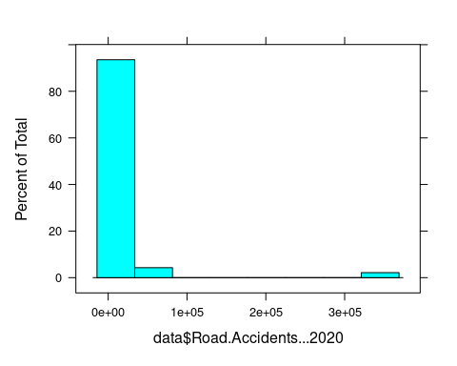

histogram(data$Road.Accidents...2021)

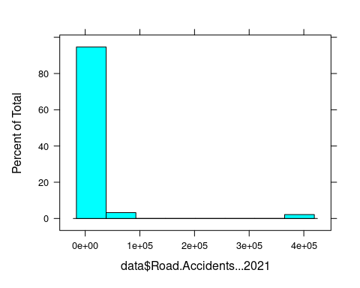

histogram(data$Road.Accidents.....Var)

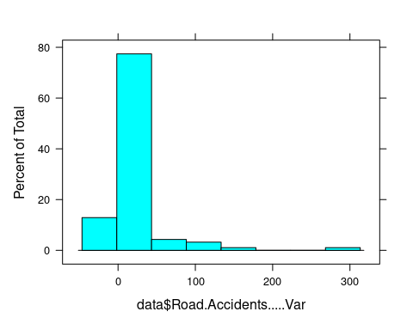

histogram(data$Railway.Accidents...2020)

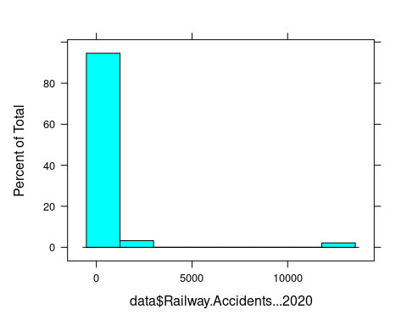

histogram(data$Railway.Accidents...2021)

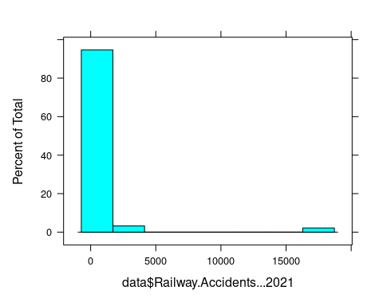

histogram(data$Railway.Accidents.....Var)

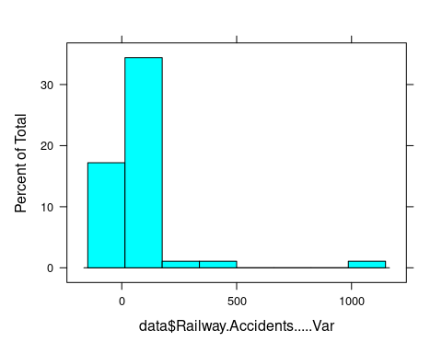

histogram(data$Railway.Crossing.Accidents...2020)

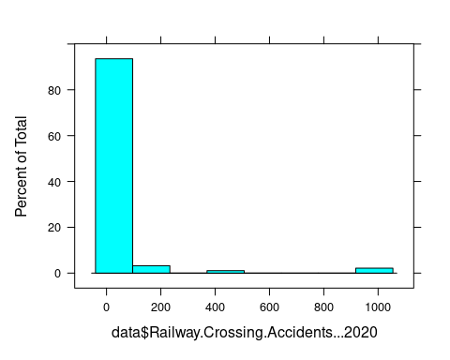

histogram(data$Railway.Crossing.Accidents...2021)

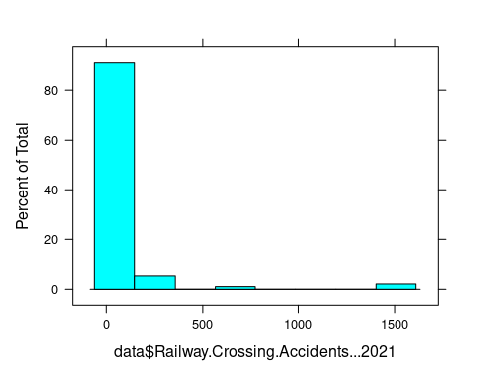

histogram(data$Railway.Crossing.Accidents.....Var)

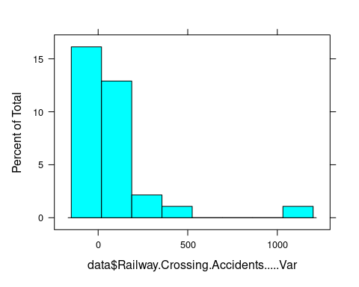

histogram(data$Total.Traffic.Accidents...2020)

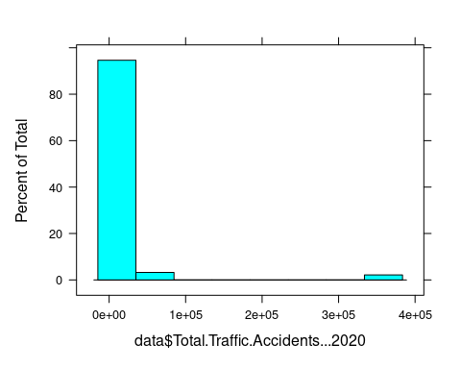

histogram(data$Total.Traffic.Accidents...2021)

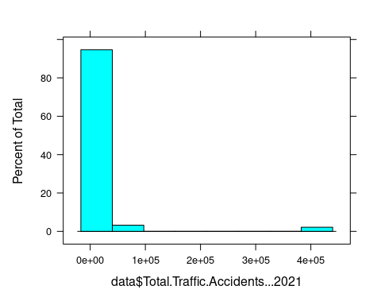

histogram(data$Total.Traffic.Accidents.....Var)

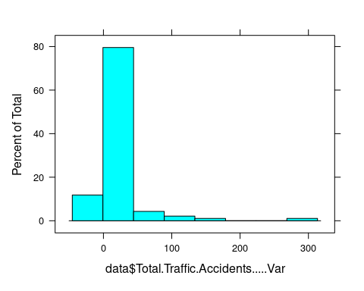

#ROAD ACCIDENTS(2020 - 2021)  
histogram(~Road.Accidents...2020|Road.Accidents...2021,data,col=c("blue","green"),main="ROAD ACCIDENTS(2020-2021)")

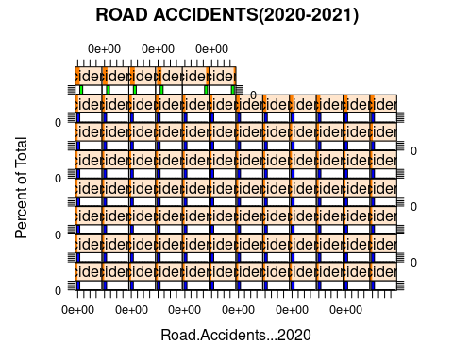

#RAILWAY ACCIDENTS(2020 - 2021)  
histogram(~Railway.Accidents...2020|Railway.Accidents...2021,data,col=c("red","purple"),main="RAILWAY ACCIDENTS(2020-2021)")

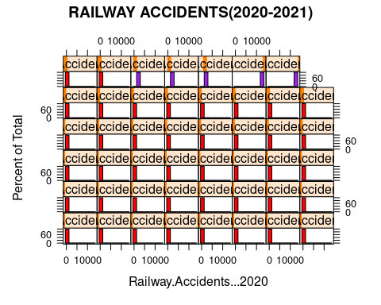

#ACCIDENT : ROAD / RAILWAY (%VAR)2020-2021  
histogram(~data$Road.Accidents.....Var|Railway.Crossing.Accidents.....Var,data,col=c("yellow","pink"),main="ROAD/RAILWAY %VAR(2020-2021)")

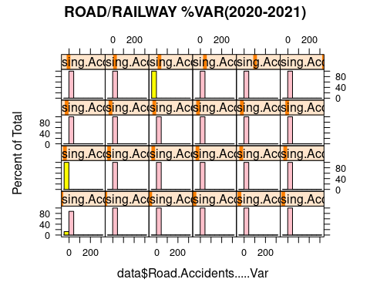

#TRAFFIC ACCIDENTS (2020 - 2021)  
histogram(~Total.Traffic.Accidents...2020|Total.Traffic.Accidents...2021,data,col=c("orange","gold"),main="TRAFFIC ACCIDENTS(2020-2021)")

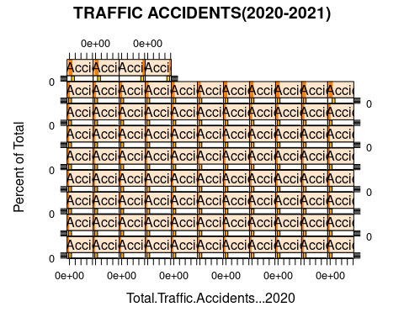

#TOTAL TRAFFIC ACCIDENTS - %VAR  
histogram(data$Total.Traffic.Accidents.....Var,col=c("green"),main="TOTAL ACCIDENT VAR")

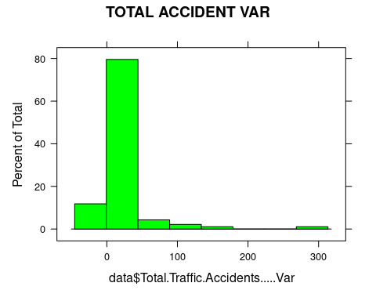

#filter  
filt1 = filter(data,Category=="State")  
filt1

## Category State.UT.City Road.Accidents...2020 Road.Accidents...2021  
## 1 State Andhra Pradesh 17924 21556  
## 2 State Arunachal Pradesh 159 261  
## 3 State Assam 6737 7069  
## 4 State Bihar 8639 9553  
## 5 State Chhattisgarh 11674 12395  
## 6 State Goa 2375 2850  
## 7 State Gujarat 13407 15200  
## 8 State Haryana 9506 10049  
## 9 State Himachal Pradesh 2235 2408  
## 10 State Jharkhand 4405 4728  
## 11 State Karnataka 34178 34647  
## 12 State Kerala 27799 32759  
## 13 State Madhya Pradesh 42396 48219  
## 14 State Maharashtra 22211 26598  
## 15 State Manipur 432 366  
## 16 State Meghalaya 205 244  
## 17 State Mizoram 47 64  
## 18 State Nagaland 27 25  
## 19 State Odisha 9817 10983  
## 20 State Punjab 5173 6097  
## 21 State Rajasthan 19121 20954  
## 22 State Sikkim 108 122  
## 23 State Tamil Nadu 45484 55682  
## 24 State Telangana 19172 21315  
## 25 State Tripura 466 478  
## 26 State Uttar Pradesh 28653 33711  
## 27 State Uttarakhand 1050 1405  
## 28 State West Bengal 10843 11501  
## 29 State Total (States) 344243 391239  
## Road.Accidents.....Var Railway.Accidents...2020 Railway.Accidents...2021  
## 1 20.3 611 755  
## 2 64.2 0 0  
## 3 4.9 413 459  
## 4 10.6 780 1147  
## 5 6.2 328 412  
## 6 20.0 23 49  
## 7 13.4 490 571  
## 8 5.7 523 806  
## 9 7.7 0 0  
## 10 7.3 274 284  
## 11 1.4 0 0  
## 12 17.8 110 171  
## 13 13.7 820 1078  
## 14 19.8 2697 3488  
## 15 -15.3 0 0  
## 16 19.0 0 0  
## 17 36.2 0 0  
## 18 -7.4 0 0  
## 19 11.9 279 306  
## 20 17.9 342 615  
## 21 9.6 429 669  
## 22 13.0 0 0  
## 23 22.4 959 1407  
## 24 11.2 333 408  
## 25 2.6 2 4  
## 26 17.7 1560 2223  
## 27 33.8 5 25  
## 28 6.1 1505 2425  
## 29 13.7 12483 17302  
## Railway.Accidents.....Var Railway.Crossing.Accidents...2020  
## 1 23.6 0  
## 2 NA 0  
## 3 11.1 8  
## 4 47.1 191  
## 5 25.6 4  
## 6 113.0 0  
## 7 16.5 1  
## 8 54.1 57  
## 9 NA 0  
## 10 3.6 22  
## 11 NA 0  
## 12 55.5 89  
## 13 31.5 144  
## 14 29.3 0  
## 15 NA 0  
## 16 NA 0  
## 17 NA 0  
## 18 NA 3  
## 19 9.7 2  
## 20 79.8 2  
## 21 55.9 0  
## 22 NA 0  
## 23 46.7 0  
## 24 22.5 0  
## 25 100.0 23  
## 26 42.5 380  
## 27 400.0 3  
## 28 61.1 83  
## 29 38.6 1012  
## Railway.Crossing.Accidents...2021 Railway.Crossing.Accidents.....Var  
## 1 0 NA  
## 2 0 NA  
## 3 3 -62.5  
## 4 163 -14.7  
## 5 0 -100.0  
## 6 0 NA  
## 7 0 -100.0  
## 8 160 180.7  
## 9 0 NA  
## 10 117 431.8  
## 11 0 NA  
## 12 121 36.0  
## 13 196 36.1  
## 14 0 NA  
## 15 0 NA  
## 16 0 NA  
## 17 0 NA  
## 18 9 200.0  
## 19 0 -100.0  
## 20 1 -50.0  
## 21 0 NA  
## 22 0 NA  
## 23 1 NA  
## 24 0 NA  
## 25 33 43.5  
## 26 575 51.3  
## 27 0 -100.0  
## 28 164 97.6  
## 29 1543 52.5  
## Total.Traffic.Accidents...2020 Total.Traffic.Accidents...2021  
## 1 18535 22311  
## 2 159 261  
## 3 7158 7531  
## 4 9610 10863  
## 5 12006 12807  
## 6 2398 2899  
## 7 13898 15771  
## 8 10086 11015  
## 9 2235 2408  
## 10 4701 5129  
## 11 34178 34647  
## 12 27998 33051  
## 13 43360 49493  
## 14 24908 30086  
## 15 432 366  
## 16 205 244  
## 17 47 64  
## 18 30 34  
## 19 10098 11289  
## 20 5517 6713  
## 21 19550 21623  
## 22 108 122  
## 23 46443 57090  
## 24 19505 21723  
## 25 491 515  
## 26 30593 36509  
## 27 1058 1430  
## 28 12431 14090  
## 29 357738 410084  
## Total.Traffic.Accidents.....Var X..Share  
## 1 20.4 5.3  
## 2 64.2 0.1  
## 3 5.2 1.8  
## 4 13.0 2.6  
## 5 6.7 3.0  
## 6 20.9 0.7  
## 7 13.5 3.7  
## 8 9.2 2.6  
## 9 7.7 0.6  
## 10 9.1 1.2  
## 11 1.4 8.2  
## 12 18.0 7.8  
## 13 14.1 11.7  
## 14 20.8 7.1  
## 15 -15.3 0.1  
## 16 19.0 0.1  
## 17 36.2 0.0  
## 18 13.3 0.0  
## 19 11.8 2.7  
## 20 21.7 1.6  
## 21 10.6 5.1  
## 22 13.0 0.0  
## 23 22.9 13.5  
## 24 11.4 5.1  
## 25 4.9 0.1  
## 26 19.3 8.6  
## 27 35.2 0.3  
## 28 13.3 3.3  
## 29 14.6 97.0

filt2 = filter(data,Category=="UT")  
filt2

## Category State.UT.City Road.Accidents...2020  
## 1 UT Andaman and Nicobar Islands 141  
## 2 UT Chandigarh 157  
## 3 UT Dadra and Nagar Haveli and Daman and Diu 98  
## 4 UT Delhi 4187  
## 5 UT Jammu and Kashmir 4861  
## 6 UT Ladakh 139  
## 7 UT Lakshadweep 1  
## 8 UT Puducherry 969  
## 9 UT Total (UTs) 10553  
## Road.Accidents...2021 Road.Accidents.....Var Railway.Accidents...2020  
## 1 117 -17.0 0  
## 2 208 32.5 0  
## 3 140 42.9 0  
## 4 4720 12.7 526  
## 5 5402 11.1 9  
## 6 237 70.5 0  
## 7 4 300.0 0  
## 8 1049 8.3 0  
## 9 11877 12.5 535  
## Railway.Accidents...2021 Railway.Accidents.....Var  
## 1 0 NA  
## 2 0 NA  
## 3 0 NA  
## 4 676 28.5  
## 5 15 66.7  
## 6 0 NA  
## 7 0 NA  
## 8 0 NA  
## 9 691 29.2  
## Railway.Crossing.Accidents...2020 Railway.Crossing.Accidents...2021  
## 1 0 0  
## 2 0 0  
## 3 0 0  
## 4 2 0  
## 5 0 7  
## 6 0 0  
## 7 0 0  
## 8 0 0  
## 9 2 7  
## Railway.Crossing.Accidents.....Var Total.Traffic.Accidents...2020  
## 1 NA 141  
## 2 NA 157  
## 3 NA 98  
## 4 -100 4715  
## 5 NA 4870  
## 6 NA 139  
## 7 NA 1  
## 8 NA 969  
## 9 250 11090  
## Total.Traffic.Accidents...2021 Total.Traffic.Accidents.....Var X..Share  
## 1 117 -17.0 0.0  
## 2 208 32.5 0.0  
## 3 140 42.9 0.0  
## 4 5396 14.4 1.3  
## 5 5424 11.4 1.3  
## 6 237 70.5 0.1  
## 7 4 300.0 0.0  
## 8 1049 8.3 0.2  
## 9 12575 13.4 3.0

filt3 = filter(data,Category=="City")  
filt3

## Category State.UT.City Road.Accidents...2020 Road.Accidents...2021  
## 1 City Agra 216 160  
## 2 City Ahmedabad 1185 1433  
## 3 City Allahabad 221 594  
## 4 City Amritsar 100 98  
## 5 City Asansol 427 285  
## 6 City Aurangabad 372 478  
## 7 City Bengaluru 3233 3213  
## 8 City Bhopal 1590 1891  
## 9 City Chandigarh (City) 157 208  
## 10 City Chennai 4389 5034  
## 11 City Coimbatore 707 866  
## 12 City Delhi (City) 4028 4505  
## 13 City Dhanbad 164 187  
## 14 City Durg Bhilainagar 603 625  
## 15 City Faridabad 524 538  
## 16 City Ghaziabad 154 296  
## 17 City Gwalior 1013 1034  
## 18 City Hyderabad 2064 2273  
## 19 City Indore 2101 2618  
## 20 City Jabalpur 1916 1802  
## 21 City Jaipur 1940 2166  
## 22 City Jamshedpur 119 152  
## 23 City Jodhpur 481 595  
## 24 City Kannur 504 1110  
## 25 City Kanpur 418 593  
## 26 City Kochi 1360 1781  
## 27 City Kolkata 1683 1519  
## 28 City Kollam 1411 1552  
## 29 City Kota 353 368  
## 30 City Kozhikode 1003 1377  
## 31 City Lucknow 1010 1063  
## 32 City Ludhiana 388 478  
## 33 City Madurai 530 618  
## 34 City Malappuram 612 686  
## 35 City Meerut 377 348  
## 36 City Mumbai 418 493  
## 37 City Nagpur 890 1024  
## 38 City Nasik 98 142  
## 39 City Patna 373 384  
## 40 City Pune 174 304  
## 41 City Raipur 907 932  
## 42 City Rajkot 432 363  
## 43 City Ranchi 247 183  
## 44 City Srinagar 276 331  
## 45 City Surat 575 670  
## 46 City Thiruvananthapuram 1214 1438  
## 47 City Thrissur 1464 1719  
## 48 City Tiruchirappalli 398 399  
## 49 City Vadodara 481 464  
## 50 City Varanasi 120 133  
## 51 City Vasai Virar 274 352  
## 52 City Vijayawada 991 1228  
## 53 City Vishakhapatnam 1144 2339  
## 54 City Total (Cities) 47829 55442  
## Road.Accidents.....Var Railway.Accidents...2020 Railway.Accidents...2021  
## 1 -25.9 0 0  
## 2 20.9 30 33  
## 3 168.8 0 0  
## 4 -2.0 0 0  
## 5 -33.3 4 7  
## 6 28.5 22 43  
## 7 -0.6 0 0  
## 8 18.9 28 31  
## 9 32.5 0 0  
## 10 14.7 0 0  
## 11 22.5 0 0  
## 12 11.8 526 676  
## 13 14.0 0 0  
## 14 3.6 14 29  
## 15 2.7 0 0  
## 16 92.2 21 18  
## 17 2.1 0 0  
## 18 10.1 1 0  
## 19 24.6 11 9  
## 20 -5.9 30 7  
## 21 11.6 101 115  
## 22 27.7 0 0  
## 23 23.7 0 7  
## 24 120.2 10 23  
## 25 41.9 31 0  
## 26 31.0 0 12  
## 27 -9.7 0 0  
## 28 10.0 1 1  
## 29 4.2 0 0  
## 30 37.3 10 9  
## 31 5.2 3 36  
## 32 23.2 0 0  
## 33 16.6 0 0  
## 34 12.1 0 5  
## 35 -7.7 0 0  
## 36 17.9 0 0  
## 37 15.1 31 37  
## 38 44.9 22 27  
## 39 2.9 0 0  
## 40 74.7 15 22  
## 41 2.8 31 47  
## 42 -16.0 10 10  
## 43 -25.9 0 0  
## 44 19.9 0 0  
## 45 16.5 11 34  
## 46 18.5 0 0  
## 47 17.4 8 0  
## 48 0.3 0 0  
## 49 -3.5 8 8  
## 50 10.8 20 29  
## 51 28.5 0 0  
## 52 23.9 0 0  
## 53 104.5 0 5  
## 54 15.9 999 1280  
## Railway.Accidents.....Var Railway.Crossing.Accidents...2020  
## 1 NA 16  
## 2 10.0 0  
## 3 NA 0  
## 4 NA 0  
## 5 75.0 0  
## 6 95.5 0  
## 7 NA 0  
## 8 10.7 2  
## 9 NA 0  
## 10 NA 0  
## 11 NA 0  
## 12 28.5 2  
## 13 NA 0  
## 14 107.1 0  
## 15 NA 0  
## 16 -14.3 0  
## 17 NA 21  
## 18 -100.0 0  
## 19 -18.2 0  
## 20 -76.7 0  
## 21 13.9 0  
## 22 NA 0  
## 23 NA 0  
## 24 130.0 0  
## 25 -100.0 34  
## 26 NA 20  
## 27 NA 0  
## 28 0.0 8  
## 29 NA 0  
## 30 -10.0 0  
## 31 1100.0 8  
## 32 NA 0  
## 33 NA 0  
## 34 NA 0  
## 35 NA 14  
## 36 NA 0  
## 37 19.4 0  
## 38 22.7 0  
## 39 NA 0  
## 40 46.7 0  
## 41 51.6 3  
## 42 0.0 0  
## 43 NA 0  
## 44 NA 0  
## 45 209.1 0  
## 46 NA 11  
## 47 -100.0 0  
## 48 NA 0  
## 49 0.0 0  
## 50 45.0 0  
## 51 NA 0  
## 52 NA 0  
## 53 NA 0  
## 54 28.1 139  
## Railway.Crossing.Accidents...2021 Railway.Crossing.Accidents.....Var  
## 1 0 -100.0  
## 2 0 NA  
## 3 0 NA  
## 4 0 NA  
## 5 0 NA  
## 6 0 NA  
## 7 0 NA  
## 8 25 1150.0  
## 9 0 NA  
## 10 0 NA  
## 11 0 NA  
## 12 0 -100.0  
## 13 0 NA  
## 14 0 NA  
## 15 0 NA  
## 16 0 NA  
## 17 18 -14.3  
## 18 0 NA  
## 19 0 NA  
## 20 1 NA  
## 21 0 NA  
## 22 0 NA  
## 23 0 NA  
## 24 0 NA  
## 25 69 102.9  
## 26 1 -95.0  
## 27 0 NA  
## 28 12 50.0  
## 29 0 NA  
## 30 6 NA  
## 31 9 12.5  
## 32 0 NA  
## 33 0 NA  
## 34 0 NA  
## 35 14 0.0  
## 36 0 NA  
## 37 0 NA  
## 38 0 NA  
## 39 0 NA  
## 40 0 NA  
## 41 0 -100.0  
## 42 0 NA  
## 43 0 NA  
## 44 0 NA  
## 45 0 NA  
## 46 17 54.5  
## 47 0 NA  
## 48 0 NA  
## 49 0 NA  
## 50 0 NA  
## 51 0 NA  
## 52 0 NA  
## 53 0 NA  
## 54 172 23.7  
## Total.Traffic.Accidents...2020 Total.Traffic.Accidents...2021  
## 1 232 160  
## 2 1215 1466  
## 3 221 594  
## 4 100 98  
## 5 431 292  
## 6 394 521  
## 7 3233 3213  
## 8 1620 1947  
## 9 157 208  
## 10 4389 5034  
## 11 707 866  
## 12 4556 5181  
## 13 164 187  
## 14 617 654  
## 15 524 538  
## 16 175 314  
## 17 1034 1052  
## 18 2065 2273  
## 19 2112 2627  
## 20 1946 1810  
## 21 2041 2281  
## 22 119 152  
## 23 481 602  
## 24 514 1133  
## 25 483 662  
## 26 1380 1794  
## 27 1683 1519  
## 28 1420 1565  
## 29 353 368  
## 30 1013 1392  
## 31 1021 1108  
## 32 388 478  
## 33 530 618  
## 34 612 691  
## 35 391 362  
## 36 418 493  
## 37 921 1061  
## 38 120 169  
## 39 373 384  
## 40 189 326  
## 41 941 979  
## 42 442 373  
## 43 247 183  
## 44 276 331  
## 45 586 704  
## 46 1225 1455  
## 47 1472 1719  
## 48 398 399  
## 49 489 472  
## 50 140 162  
## 51 274 352  
## 52 991 1228  
## 53 1144 2344  
## 54 48967 56894  
## Total.Traffic.Accidents.....Var X..Share  
## 1 -31.0 0.3  
## 2 20.7 2.6  
## 3 168.8 1.0  
## 4 -2.0 0.2  
## 5 -32.3 0.5  
## 6 32.2 0.9  
## 7 -0.6 5.6  
## 8 20.2 3.4  
## 9 32.5 0.4  
## 10 14.7 8.8  
## 11 22.5 1.5  
## 12 13.7 9.1  
## 13 14.0 0.3  
## 14 6.0 1.1  
## 15 2.7 0.9  
## 16 79.4 0.6  
## 17 1.7 1.8  
## 18 10.1 4.0  
## 19 24.4 4.6  
## 20 -7.0 3.2  
## 21 11.8 4.0  
## 22 27.7 0.3  
## 23 25.2 1.1  
## 24 120.4 2.0  
## 25 37.1 1.2  
## 26 30.0 3.2  
## 27 -9.7 2.7  
## 28 10.2 2.8  
## 29 4.2 0.6  
## 30 37.4 2.4  
## 31 8.5 1.9  
## 32 23.2 0.8  
## 33 16.6 1.1  
## 34 12.9 1.2  
## 35 -7.4 0.6  
## 36 17.9 0.9  
## 37 15.2 1.9  
## 38 40.8 0.3  
## 39 2.9 0.7  
## 40 72.5 0.6  
## 41 4.0 1.7  
## 42 -15.6 0.7  
## 43 -25.9 0.3  
## 44 19.9 0.6  
## 45 20.1 1.2  
## 46 18.8 2.6  
## 47 16.8 3.0  
## 48 0.3 0.7  
## 49 -3.5 0.8  
## 50 15.7 0.3  
## 51 28.5 0.6  
## 52 23.9 2.2  
## 53 104.9 4.1  
## 54 16.2 100.0

#remove null data/group_by data  
sum(is.null(data))

## [1] 0

dplyr::group_by(data)

## # A tibble: 93 × 15  
## Category State.UT.C…¹ Road.…² Road.…³ Road.…⁴ Railw…⁵ Railw…⁶ Railw…⁷ Railw…⁸  
## <chr> <chr> <int> <int> <dbl> <int> <int> <dbl> <int>  
## 1 State Andhra Prad… 17924 21556 20.3 611 755 23.6 0  
## 2 State Arunachal P… 159 261 64.2 0 0 NA 0  
## 3 State Assam 6737 7069 4.9 413 459 11.1 8  
## 4 State Bihar 8639 9553 10.6 780 1147 47.1 191  
## 5 State Chhattisgarh 11674 12395 6.2 328 412 25.6 4  
## 6 State Goa 2375 2850 20 23 49 113 0  
## 7 State Gujarat 13407 15200 13.4 490 571 16.5 1  
## 8 State Haryana 9506 10049 5.7 523 806 54.1 57  
## 9 State Himachal Pr… 2235 2408 7.7 0 0 NA 0  
## 10 State Jharkhand 4405 4728 7.3 274 284 3.6 22  
## # … with 83 more rows, 6 more variables:  
## # Railway.Crossing.Accidents...2021 <int>,  
## # Railway.Crossing.Accidents.....Var <dbl>,  
## # Total.Traffic.Accidents...2020 <int>, Total.Traffic.Accidents...2021 <int>,  
## # Total.Traffic.Accidents.....Var <dbl>, X..Share <dbl>, and abbreviated  
## # variable names ¹​State.UT.City, ²​Road.Accidents...2020,  
## # ³​Road.Accidents...2021, ⁴​Road.Accidents.....Var, …

group_by(data)

## # A tibble: 93 × 15  
## Category State.UT.C…¹ Road.…² Road.…³ Road.…⁴ Railw…⁵ Railw…⁶ Railw…⁷ Railw…⁸  
## <chr> <chr> <int> <int> <dbl> <int> <int> <dbl> <int>  
## 1 State Andhra Prad… 17924 21556 20.3 611 755 23.6 0  
## 2 State Arunachal P… 159 261 64.2 0 0 NA 0  
## 3 State Assam 6737 7069 4.9 413 459 11.1 8  
## 4 State Bihar 8639 9553 10.6 780 1147 47.1 191  
## 5 State Chhattisgarh 11674 12395 6.2 328 412 25.6 4  
## 6 State Goa 2375 2850 20 23 49 113 0  
## 7 State Gujarat 13407 15200 13.4 490 571 16.5 1  
## 8 State Haryana 9506 10049 5.7 523 806 54.1 57  
## 9 State Himachal Pr… 2235 2408 7.7 0 0 NA 0  
## 10 State Jharkhand 4405 4728 7.3 274 284 3.6 22  
## # … with 83 more rows, 6 more variables:  
## # Railway.Crossing.Accidents...2021 <int>,  
## # Railway.Crossing.Accidents.....Var <dbl>,  
## # Total.Traffic.Accidents...2020 <int>, Total.Traffic.Accidents...2021 <int>,  
## # Total.Traffic.Accidents.....Var <dbl>, X..Share <dbl>, and abbreviated  
## # variable names ¹​State.UT.City, ²​Road.Accidents...2020,  
## # ³​Road.Accidents...2021, ⁴​Road.Accidents.....Var, …

#plot  
attach(data)  
  
bwplot(Road.Accidents.....Var,data)

## Warning in bwplot.numeric(Road.Accidents.....Var, data): explicit 'data'  
## specification ignored

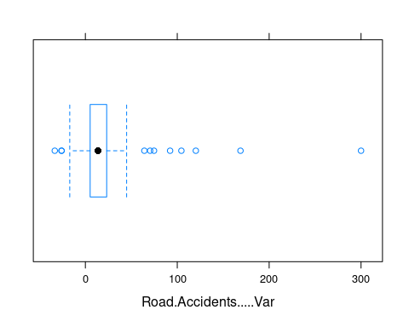

bwplot(Railway.Accidents.....Var,data)

## Warning in bwplot.numeric(Railway.Accidents.....Var, data): explicit 'data'  
## specification ignored

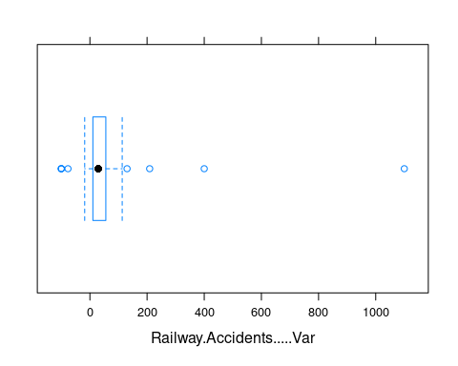

bwplot(Railway.Crossing.Accidents.....Var,data)

## Warning in bwplot.numeric(Railway.Crossing.Accidents.....Var, data): explicit  
## 'data' specification ignored

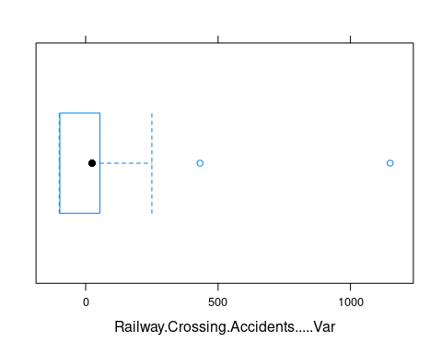

bwplot( Total.Traffic.Accidents.....Var ,data)

## Warning in bwplot.numeric(Total.Traffic.Accidents.....Var, data): explicit  
## 'data' specification ignored

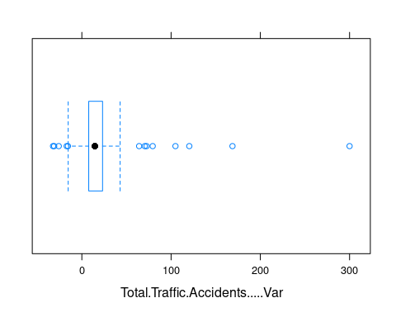

bwplot( Road.Accidents...2020-Road.Accidents...2021,data=data,  
 main = "Road accidents",  
 xlab = "Road accidents(2020)",  
 ylab = "Road accidents(2021)")

## Warning in bwplot.numeric(Road.Accidents...2020 - Road.Accidents...2021, :  
## explicit 'data' specification ignored

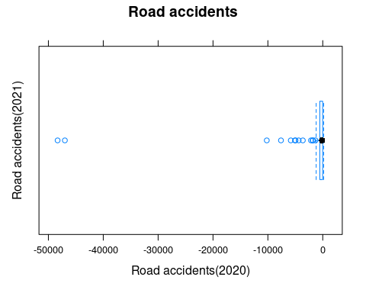

bwplot(Railway.Accidents...2020-Railway.Accidents...2021,data=data,  
 main = "Railway accidents",  
 xlab = "2020",  
 ylab = "2021")

## Warning in bwplot.numeric(Railway.Accidents...2020 - Railway.Accidents...2021,  
## : explicit 'data' specification ignored

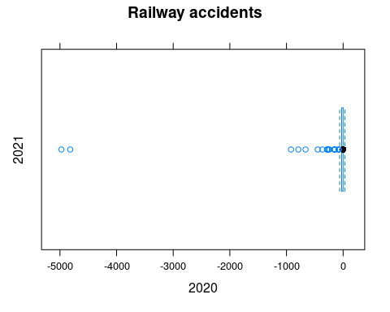

bwplot(Road.Accidents...2020-Railway.Accidents...2020,data=data,  
 main = "2020",  
 xlab = "analyse1",  
 ylab = "analyse2")

## Warning in bwplot.numeric(Road.Accidents...2020 - Railway.Accidents...2020, :  
## explicit 'data' specification ignored

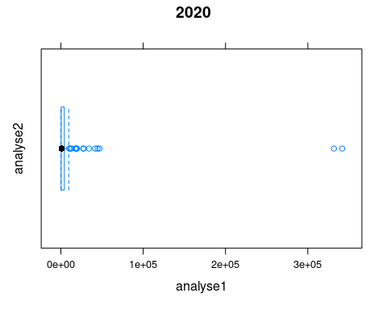

bwplot(Road.Accidents...2021- Railway.Accidents...2021,data=data,  
 main = "2021",  
 xlab = "analyse1",  
 ylab = "analyse2")

## Warning in bwplot.numeric(Road.Accidents...2021 - Railway.Accidents...2021, :  
## explicit 'data' specification ignored

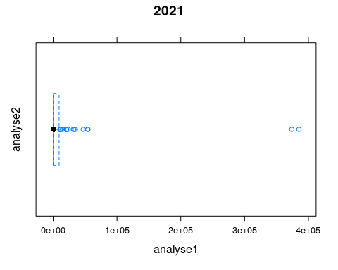

bwplot(Road.Accidents.....Var-Railway.Accidents.....Var,data=data,  
 main = "ACCIDENTS",  
 xlab = "Road accidents(var)2020-2021",  
 ylab = "Railway.Accidents(Var)2020-2021")

## Warning in bwplot.numeric(Road.Accidents.....Var - Railway.Accidents.....Var, :  
## explicit 'data' specification ignored

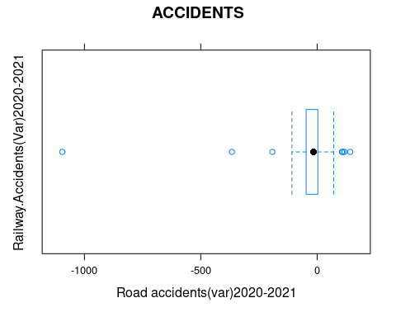

bwplot(Road.Accidents.....Var-Railway.Accidents.....Var-Railway.Crossing.Accidents.....Var-Total.Traffic.Accidents.....Var,data=data,  
 main = "VAR-ACCIDENTS",  
 xlab = "analysing1",  
 ylab = "analysing2")

## Warning in bwplot.numeric(Road.Accidents.....Var - Railway.Accidents.....Var -  
## : explicit 'data' specification ignored

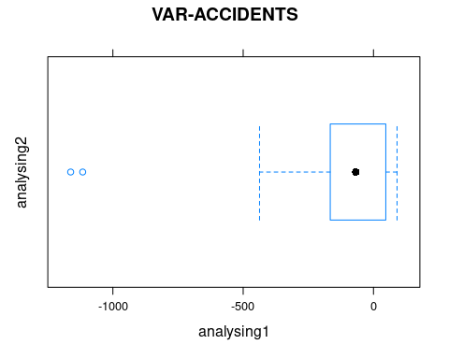

plot(x = data$Road.Accidents.....Var,  
 xlab = "Road",  
 xlim = c(2.5,5),  
 main = "road accident")

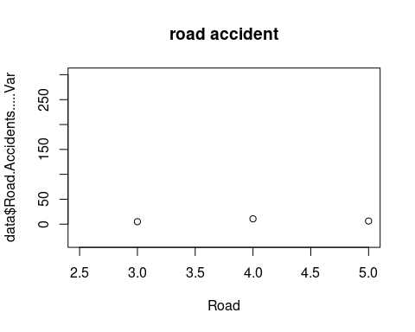

plot(x = data$Railway.Accidents.....Var,  
 xlab = "Railway",  
 xlim = c(2.5,5),  
 main = "railway accident")

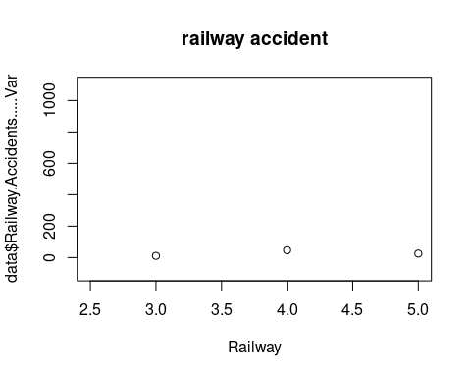

plot(x = data$Railway.Crossing.Accidents.....Var,  
 xlab = "Crossing accidents",  
 xlim = c(2.5,5),  
 main = "accidents")

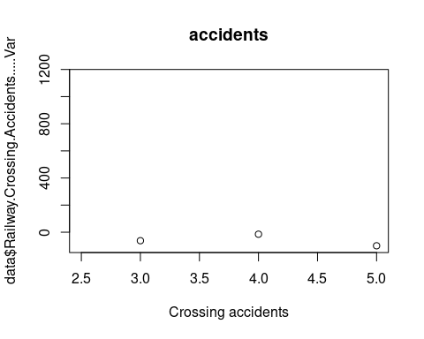

plot(x = data$ Total.Traffic.Accidents.....Var,  
 xlab = "total traffic accidents",  
 xlim = c(2.5,5),  
 main = "Traffic Accidents"  
)

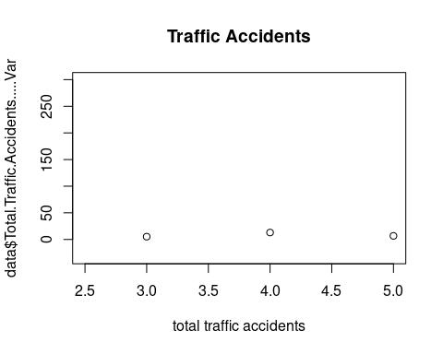

**INFERENCE :**

STATE WISE :

* This dataset shows that the total number of traffic accidents in 2020 was 357738, while in 2021 it increased to 410084, with an overall increase of 14.6%. Road accidents accounted for the highest number of traffic accidents, with an increase of 13.7%, followed by railway accidents, which increased by 38.6%. Railway crossing accidents saw the most drastic decrease of 62.5% in 2021. The states of West Bengal, Uttar Pradesh, and Tamil Nadu saw the highest percentage increases in total traffic accidents.

CITY WISE :

* The data from this dataset shows that road, railway and traffic accidents have increased by 15.9%, 28.1% and 23.7% respectively in the cities of India from 2020 to 2021. Mumbai and Delhi have seen the highest increase in road accidents, while Vishakhapatnam and Kannur had the highest increase in total traffic accidents. The highest railway accidents are seen in Ahmedabad and Bhopal, while Allahabad has experienced the highest increase in railway crossing accidents.

UT :

* This dataset shows a general increase in road, railway and total traffic accidents across the Union Territories in India between 2020 and 2021. The highest increase was observed in Ladakh with a 70.5% increase in road accidents, followed by Andaman and Nicobar Islands with a 32.5% increase in road accidents. The highest increase in railway accidents was observed in Jammu and Kashmir with a 66.7% increase. The highest increase in total traffic accidents was observed in Delhi with a 14.4% increase. Overall, there was an increase of 13.4% in total traffic accidents across the Union Territories in India between 2020 and 2021.

**INSIGHTS :**

STATE WISE :

1. Road Accidents: Road accidents have increased by 13.7% in 2020 compared to 2021, with Andhra Pradesh showing the highest increase of 20.3%.

2. Railway Accidents: Railway accidents have increased by 38.6% in 2020 compared to 2021, with Uttar Pradesh showing the highest increase of 42.5%.

3. Railway Crossing Accidents: Railway crossing accidents have decreased by an average of 14.7% in 2020 compared to 2021, with Chhattisgarh showing the highest decrease of 100%.

4. Total Traffic Accidents: The total number of traffic accidents has increased by 14.6% in 2020 compared to 2021, with Tamil Nadu showing the highest increase of 22.9%.

5. State Shares: The top 5 states in terms of accident shares are Tamil Nadu (13.5%), Madhya Pradesh (11.7%), Uttar Pradesh (8.6%), Karnataka (8.2%) and Maharashtra (7.1%).

CITY WISE :

1. The overall growth rate of cities across India is 15.9%.

2. Cities like Durg Bhilainagar, Kolkata, and Jabalpur have seen a decline in growth rate compared to other cities.

3. Dhanbad, Kochi, and Kannur have the highest growth rate at 120.2%, 37.3%, and 37.4% respectively.

4. Delhi, Chennai, and Mumbai are the three cities with the highest population growth.

5. Patna, Madurai, and Jamshedpur have the lowest population growth rate at 2.9%, 16.6%, and 27.7% respectively.

6. Cities like Bhopal, Indore, and Hyderabad have seen an increase in their population growth rate in the last year.

7. Out of the total population, 999 people have migrated to cities, while 1280 people have left the cities.

8. Cities like Kanpur, Nasik, and Faridabad have seen an increase in their migration rate.

UT(UNION TERRITORY) :

1. The highest increase in road accidents has been seen in Ladakh, where there has been a 70.5% increase in accidents.

2. The highest increase in railway accidents has been seen in Jammu and Kashmir, where there has been a 66.7% increase in accidents.

3. The highest decrease in railway crossing accidents has been seen in Delhi, where there has been a 100% decrease in accidents.

4. The overall traffic accident rate has increased by 14.6% from 2020 to 2021, indicating an increase in unsafe driving practices.

**HOW IT IS VISUALIZED ON :**

1. The total number of road accidents in India has increased from 2020 to 2021.

2. The total number of railway accidents in India has increased from 2020 to 2021.

3. The total number of railway crossing accidents in India has decreased from 2020 to 2021.

4. The total number of traffic accidents in India has increased from 2020 to 2021.

* Road accidents have increased significantly in 2021 as compared to 2020 across all states in India, Railway accidents have increased by 11.1% in 2021 as compared to 2020, Railway crossing accidents have decreased by 62.5% in 2021 as compared to 2020, Total traffic accidents have increased by 14.6% in 2021 as compared to 2020.
* Overall increase in the number of traffic accidents across all cities in India, with an increase of 16.2% from 2020 to 2021.
* The data is from the Ministry of Road Transport and Highways, Government of India and is an estimate of the number of road, railway, and railway crossing accidents in 2020 and 2021. The data also shows the percentage change in accidents from 2020 to 2021.

**SUMMARY:**

* Summary of accidents is a report that summarizes the number, type, and cause of accidents that have occurred in a certain area or over a specific period of time. It can be used to identify potential safety concerns or to track changes in safety trends. The report typically includes information about the number of people involved, the type of accident, the time and location, the cause of the accident, and any resulting injuries or fatalities. This data can be used to analyze safety trends and to identify areas that need additional safety measures.

|  |  |
| --- | --- |
|  |  |